**HORMISDALLEN SCHOOL - KYEBANDO**

**PRE- PLE SET 5 EXAMINATIONS, 2023**

**PRIMARY SEVEN SCIENCE**

**Duration: 2 Hours 15 Minutes**

**NAME: ______________________________________________ STREAM: _________**

INDEX NO.

EMIS NO.

**SECTION A**

1. Define the term skeleton.

………………………………………………………………………………………………….

1. Name the gas that is used in leguminous plants to make proteins.

……………………………………………………………………………….……………….

1. Identify any one state of matter through which heat travels by convection.

……………………………………………………………………………….……………….

1. Why is it important to give first aid to a casualty?

……………………………………………………………………………….……………….

1. Why should a living house have proper ventilation?

……………………………………………………………………………….……………….

1. Give any one example of a root tuber.

………………………………………………………………………………………………….

1. State any one sign of dehydration in babies.

……………………………………………………………………………….……………….

1. In the space below, draw the diagram of a convex lens.
2. Identify any one method of castration.

……………………………………………………………………………….……………….

1. State any one effect of heat on matter.

……………………………………………………………………………….……………….

1. Write down any one example of a disease which can be prevented by drinking boiled water.

……………………………………………………………………………….……………….

1. Write HIV in full.

……………………………………………………………………………….………………

.

1. How does an energy saving stove help to conserve the environment?

……………………………………………………………………………….……………….

1. State any one role of children at home.

………………………...……………………………………………………….……………….

**Study the diagram below carefully and use it to answer the questions that follow.**

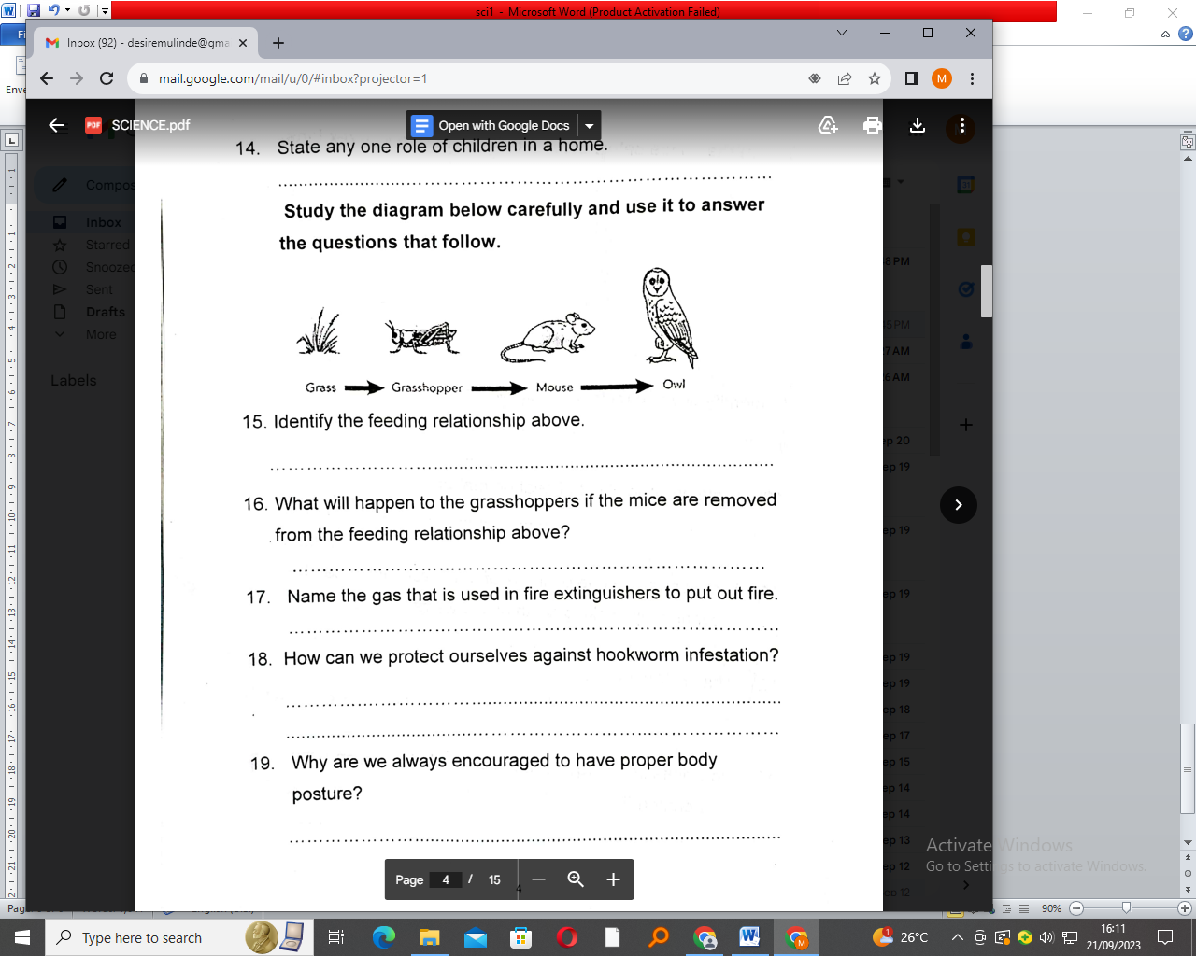

1. Identify the feeding relationship above.

……………………………………………………………………………….……………….

1. What will happen to the grasshoppers if the mice are removed from the feeding relationship above?

……………………………………………………………………………….……………….

1. Name the gas that is used in fire extinguishers to put out fire.

………………………………………………………………………………………………..

1. How can we protect ourselves against hookworm infestation?

…………………………………………………………………………………………….….

1. Why are we always encouraged to have proper body posture?

…………………………………………………………………………………………….….

1. Mention any one condition that leads to short circuits.

…………………………………………………………………………………………….….

1. Suggest any one danger of antisocial behaviours among the youths.

……………………………………………………………………………………….…….....

1. Identify the class of food obtained from beans, fish and milk.

……………………………………………………………………………………….……….

**The diagram below shows an item found in a poultry house. Use it to answer questions 23 and 24.**

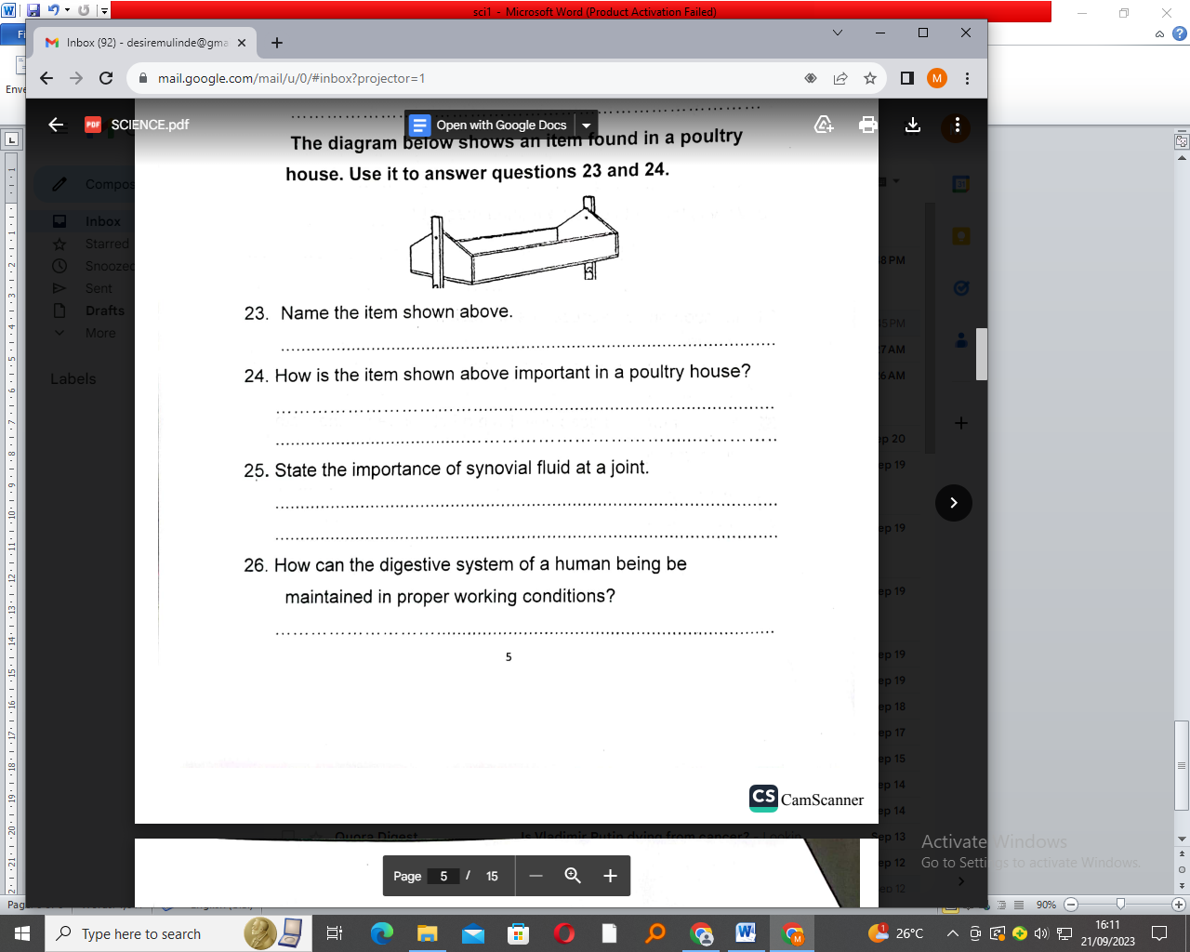

1. Name the item shown above.

………………………………………………………………………………………….…….

1. How is the item shown above important in a poultry house

………………………………………………………………………………………………….

1. State the importance of synovial fluid at a joint.

………………………………………………………………………………….…………….

1. How can the digestive system of a human being be maintained in proper working conditions?

…………………………………………………………………………………….………….

1. Give any one reason why we should always follow doctor’s advice when taking drugs.

……………………………………………………………………………….……………….

1. Name one product got from milk.

……………………………………………………………………………….……………….

1. Point out any one sign of kwashiorkor in babies.

…………………………………………………………………………………….………….

1. Why is the earth called a natural magnet?

…………………………………………………………………………………………….….

1. Mention any one cause of soil erosion.

………………………………………………………………………………………….…….

1. By what process does heat from a flat iron reach the cloth when ironing?

……………………………………………………………………………………………….

1. State the function of the blood cell shown below.

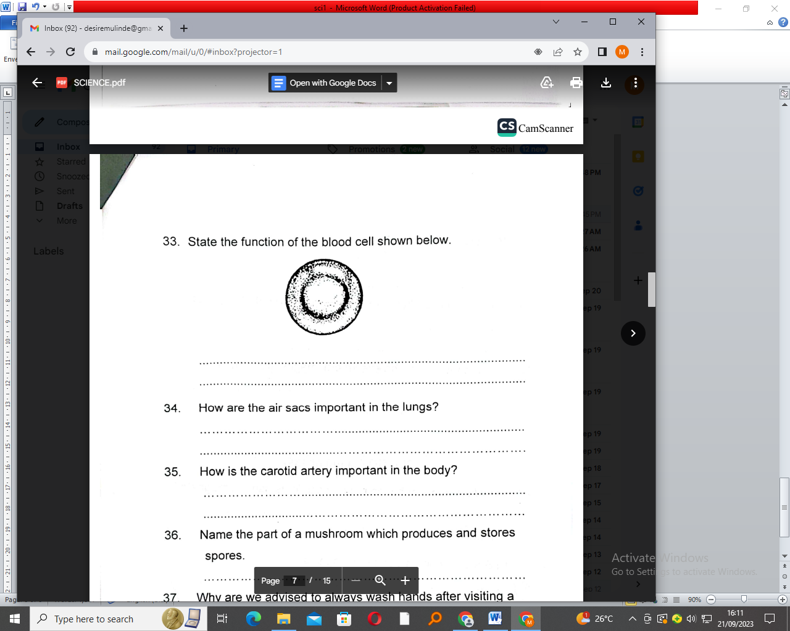………………………………………………………………………….….

1. How are the air sacs important in the lungs?

………………………………………………………………………………………………….

1. How is the carotid artery important in the body?

………………………………………………………………………………………………..

1. Name the part of a mushroom which produces and stores spores.

…………………………………………………………………………………………….….

1. Why are we advised to always wash hands after visiting the toilet or latrine?

………………………………………………………………………………………….…….

1. What is adolescence?

……………………………………………………………………………………………….

………………………………………………………………………………………………..

1. State any one characteristic of insect pollinated flowers.

…………………………………………….………………………………………………….

1. Name the part of the eye where images are formed.

……………………………………….……………………………………………………….

**SECTION B**

1. a) What is meant by the magnetic field used in magnets?

………………………………………………………………………………………………………..………………………………………………………………………………………….

b) State any one property of magnets.

………...……………………………….……………………………………………………….

c) Give any two materials which can be attracted by a magnet.

i)……………………………………….……………………………………………………….

ii)…………………………………………………………………………………………….....

1. a) State any two functions of a leaf to a plant.

i)……………………………………….……………………………………………………….

ii)…………………………………………………………………………………………….....

b) Identify any one raw material used by plants to make food.

……………………………………….……………………………………………………….

c) How do animals benefit from the process of photosynthesis?

……………….……………….……………….……………….……………….………………

1. The diagram below shows an electric bulb. Use it to answer the questions that follow.

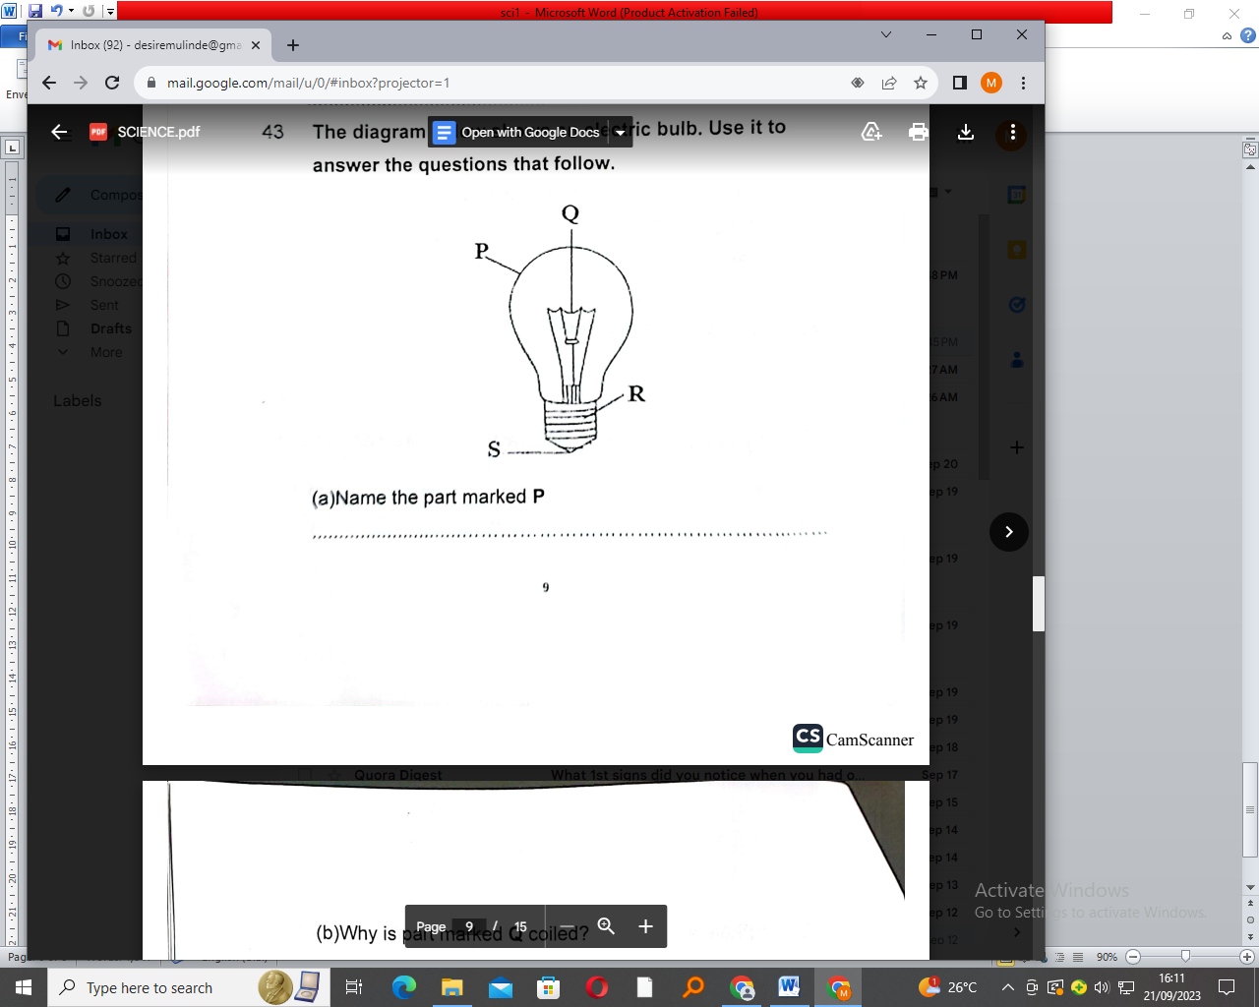

1. Name the part marked P.

………………………………………….……………………………………………….

b) Why is part marked Q coiled?

……………………………………….……………………………………………………….

c) Mention any one gas found in the bulb.

……………….……………….……………….……………….……………….………………

d) State the energy transformation that takes place in the bulb when it is working.

………………………………………………………………………………………………….

1. a) What is reflection?

……………………………………………….……………………………………………….

b) What causes reflection?

…………………………… ……………….…………………………………………………

c) How do we call the angle between the normal and the reflected rays?

………………………… ……………….…………………………………………………

d) How can total internal reflection be prevented in a pin-hole camera?

………………………………………………………………………………………………..

1. a) What is the difference between a fruit and a seed?

……………………………………………………………………………………………………………………………………………………………………………………………………

b) Give one example of each of the following;

i) drupe…...…………………………………………………………………………………….

ii) pome………………………….……………….…………………………………………....

iii) berry………………………………………………………………………………………..

1. a) What are vertebrates?

…………………………………………………………………….………………………….

b) Give two groups of vertebrates which are warm blooded.

i)…………………………………………………… ……………….………………………

ii)…………………………………………………… ……………….……………………..

c) Why are reptiles grouped under cold blooded vertebrates?

………………………………………………………………………………………………..

1. a) Suggest any two importance of wind in the environment.
2. ……………………………………………………………………………………………….
3. …………………..…………………………………………………………………………..
4. Give to ways wind can be dangerous in the environment.
5. ……………………………………………………………………………………………….
6. …………………..…………………………………………………………………………..
7. The diagram below shows the human eye. Use it to answer the questions that follow.

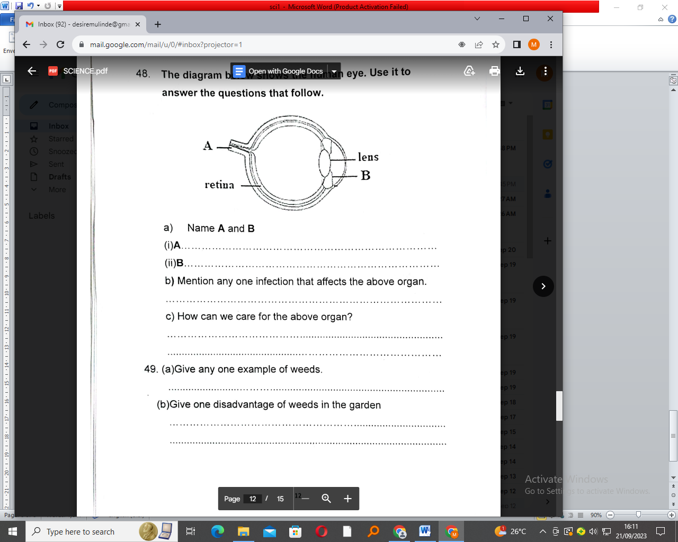

1. Name A and B.

i) A……………………………………………………………………….…………………….

ii) B……………………………………………………………………….…………………….

1. Mention one infection that affects the above organ.

...………………………………………………… ……………….………………………....

1. How can we care for the above organ?

………………………………………………………………….………………………….

…………………………………………………………………….………………………….

1. a) Give any one example of weeds.

..………………………………………… ……………….………………………………....

b) Give one disadvantage of weeds in the garden.

…..………………………………………… ……………….………………………………....

c) Point out any two ways of controlling weeds in the garden.

i)..……………………………………………………………………….…………………….

ii) ………………………………………………………….………………………………….

1. a) Name any one drug found in tobacco.

………………………………………………………………….……………………….....

b) Give two reasons why people smoke.

i)…………………………………………… ……………….……………………………..

ii)………………………………………… ……………….……………………………….

c) How is tobacco growing important in a community?

……………………………………………………………….…………………………….

1. a) Give two diseases which attack bananas.

i)…………………………………………… ……………….……………………………..

ii)………………………………………… ……………….……………………………….

b) State any one way of controlling diseases in a banana plantation.

……………………………………………………………………………………………….

c) Why do farmers carry out mulching in a banana plantation?

……………………………………………………………….…………………………….

1. a) Mention any two activities carried out on a school health parade.

i)…………………………………………… ……………….……………………………..

ii)………………………………………… ……………….……………………………….

b) How does a school health parade promote good health of pupils?

……………………………………………………………………………………………….

c) Name any one member of a school health committee.

……………………………………………………………………………………………….

1. Use the diagram below to answer the questions that follow.

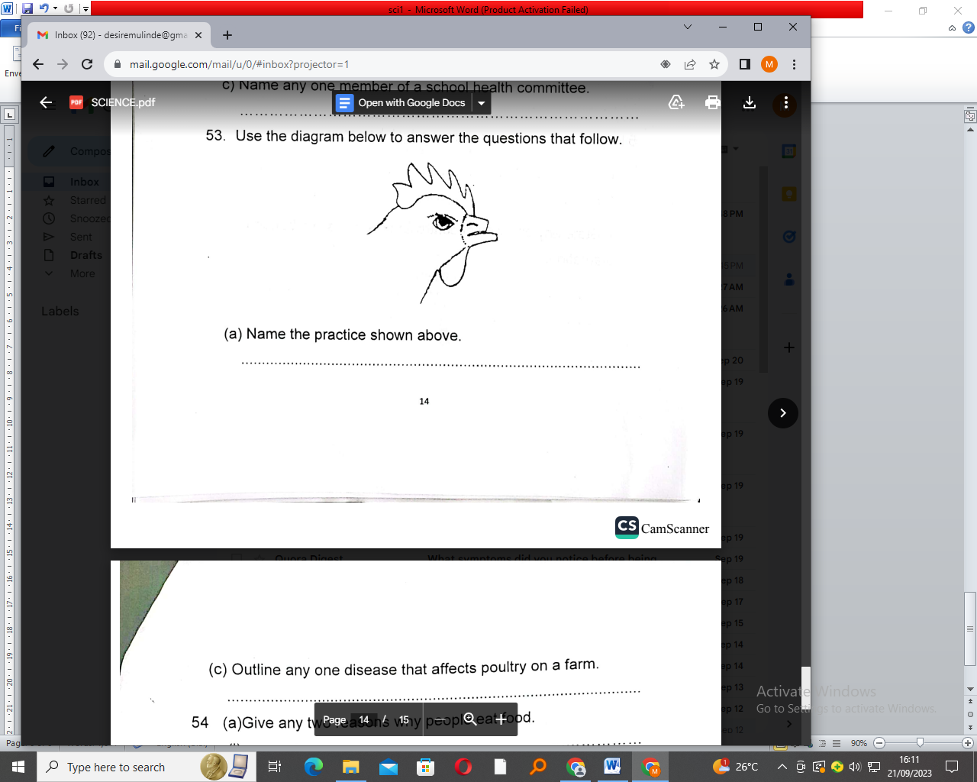

1. Name the practice shown above.

…………………………………………………………………………………………………

1. Outline any one disease that affects poultry on a farm.

…………………………………………………………………………………………………

1. a) Give two reasons why people eat food.

i)………………………………… ……………………………………………………………

ii)……………………………………………………………………………………………..

b) Write the first 2Fs as used in 4Fs.

i)………………………………………………………………………………………………

ii)……………………………………………………………………………………………..

1. a) State any two characteristics of insects.

i)………………………………………………………………………………………………

ii)……………………………………………………………………………………………..

b) Which part of an insect helps to balance in air during flight?

………………………………………………………………………………………………….

1. How are houseflies important in a pit latrine?

…………………………………………………………………………………………………..

**\*\*\*END\*\*\***